PRACTICAL : 2 & ASSIGNMENT : 3

* **Aim :**

Implement copy command using open, create, read, write, access and close system call. Be sure to include all necessary error checking including, ensuring the source file exists. Test your program with following specifications.

* File extension with .txt, .c, .zip, .exe, .tar
* b. Copy the whole directory.Ls

Also Implement copy command by using following option

* ./cp sourcefile destinationfile
* ./cp sourcedir destinationdir
* ./ sourcefile destinationdir
* **Code :**

#include<stdio.h>

#include<stdlib.h>

#include<sys/stat.h>

#include<unistd.h>

#include<fcntl.h>

#include<dirent.h>

#include<string.h>

char path[]="";

char *p;

void cpy_dir(char *basePath,const int root);

void copy(int old_file,int new_file);

int main(int argc,char*argv[])

{

if(strcmp(argv[3],"1")==0)

{

int old_file,new_file;

int ac1=access(argv[1],F_OK);

new_file=creat(argv[2],0666);

int ac2=access(argv[2],F_OK);

if(ac1==-1)

{

printf("\n\tyou can't access this F1.txt\n");

}

else

printf("\n\tyou can access %s\n",argv[1]);

if(ac2==-1)

{

printf("you can't access this\n");

}

else

printf("\tyou can access %s\n\n",argv[2]);

old_file=open(argv[1],O_RDONLY);

if(old_file==-1)

{

printf("\nError in file opening\n");

exit(1);

}

new_file=creat(argv[2],0666);

if(new_file==-1)

{

printf("can't open the file\n");

}

copy(old_file,new_file);

exit(0);

}

if(strcmp(argv[3],"3")==0)

{

int s_file,d_file,c;

DIR *dest;

char pathfile[260];

sprintf(pathfile,"%s/%s",argv[2],argv[1]);

int ac1=access(argv[1],F_OK);

dest=opendir(argv[2]);

if(!dest)

{

c=mkdir(argv[2],0777);

printf("\n\tNew dir created\n");

}

d_file=open(pathfile,O_RDWR|O_APPEND|O_CREAT);

printf("\tPath : %s\n",pathfile);

int ac2=access(pathfile,F_OK);

if(ac1==-1)

{

printf("you can't access this argv[1]\n");

}

else

printf("\tyou can access %s\n",argv[1]);

if(ac2==-1)

{

printf("you can't access %s \n",pathfile);

}

else

printf("\tyou can access fless %s\n",pathfile);

s_file=open(argv[1],O_RDONLY);

if(s_file==-1)

{

printf("Error in opening %s\n",argv[1]);

exit(1);

}

if(d_file==-1)

{

printf("Error in opening %s\n",argv[2]);

}

copy(s_file,d_file);

exit(0);

}

if(strcmp(argv[3],"2")==0)

{

p=argv[2];

copy_dir(argv[1],0);

}

}

void copy_dir(char *basePath, const int root)

{

int i,d_dir;

char path[1000],d_path[1000],s_path[1000];

struct dirent *dp;

DIR *dir3 = opendir(basePath);

sprintf(d_path,"%s/%s",p,basePath);

int c=mkdir(d_path,0777);

d_dir=open(d_path,O_RDWR|O_APPEND|O_CREAT);

if (!dir3)

return;

while ((dp = readdir(dir3)) != NULL)

{

if (strcmp(dp->d_name, ".") != 0 && strcmp(dp->d_name, "..") != 0)

{

if(dp->d_type!=DT_DIR)

{

sprintf(s_path,"%s/%s",basePath,dp->d_name);

int s_file=open(s_path,O_RDONLY);

sprintf(d_path,"%s/%s/%s",p,basePath,dp->d_name);

int d_file=creat(d_path,0666);

int ac2=access(d_path,F_OK);

int ac1=access(basePath,F_OK);

/*if(ac1==-1){

printf("you can't access this S_FILE");}

else

printf("\tyou can access S_FILE\n");

if(ac2==-1){

printf("you can't access D_FILE \n");}

else

printf("\tyou can access fless D_FILE\n");*/

if(s_file==-1)

printf("\tError in s_file\n");

if(d_file==-1)

printf("\tError in d_file\n");

copy(s_file,d_file);

}

if(dp->d_type==DT_DIR)

{

strcpy(path, basePath);

strcat(path, "/");

strcat(path, dp->d_name);

copy_dir(path,root + 2);

}

}

}

closedir(dir3);

}

void copy(int op,int cl)

{

char buffer[4096];

int count;

while((count=read(op,buffer,sizeof(buffer)))>0)

{

write(cl,buffer,count);

}

}

* **Output :**
* **./cp sourcefile destinationfile**

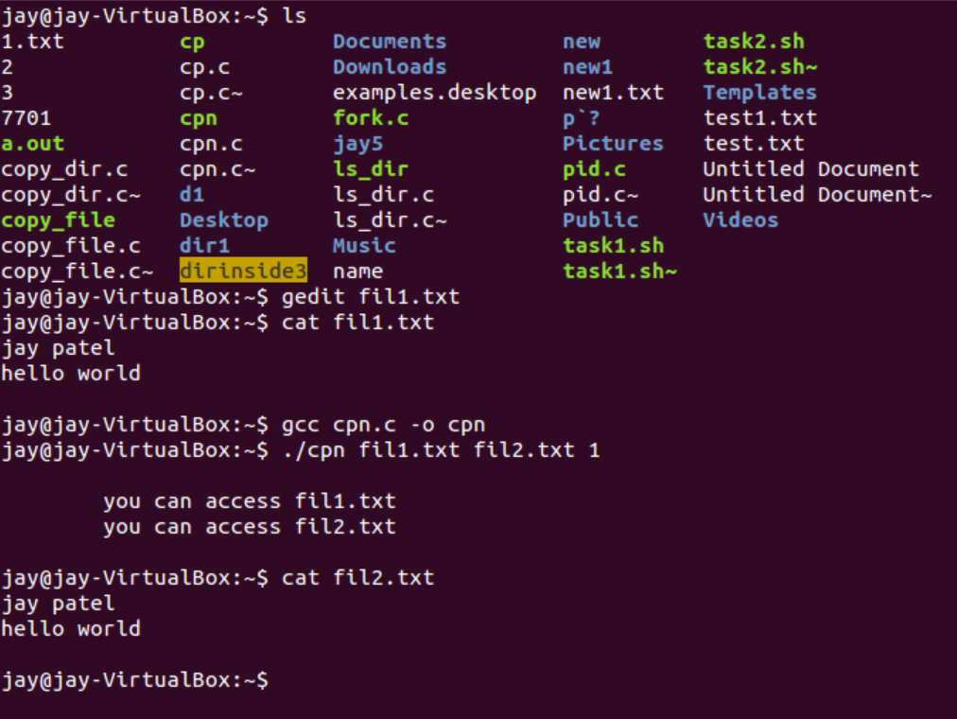

* In this we have copied fil1.txt to fil2.txt , in this it will create destination file if it’s not exist.
* **./cp sourcedir destinationdir**

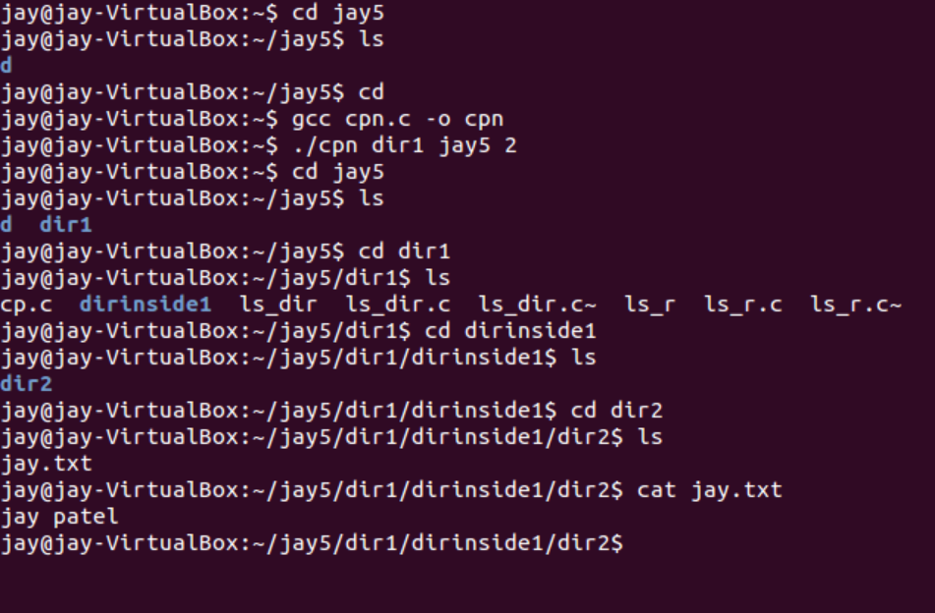

* In this we have copied whole dir1 directory into jay5 directory.
* You can see that whole directory with it’s inner dir and file with contain is copied in jay5 dir.
* **./ sourcefile destinationdir**

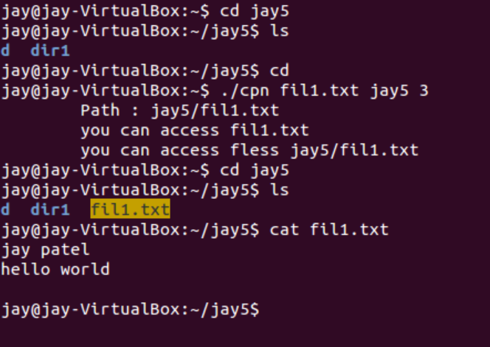

* In this we have copied file1.txt in jay5 directory with it’s contain.
* **Conclusion :**
* In this practical we have studied about copy command and also implement copy command using open , create , read , write , close , access system.
* Also implement copy command with necessary options.